NAME: MUHAMMAD SYAHMI FARIS BIN RUSLI
MATRIC NUMBER: A23CS0138
SECTION: 2
LECTURER NAME: PUAN ARYATI BINTI BAKRI
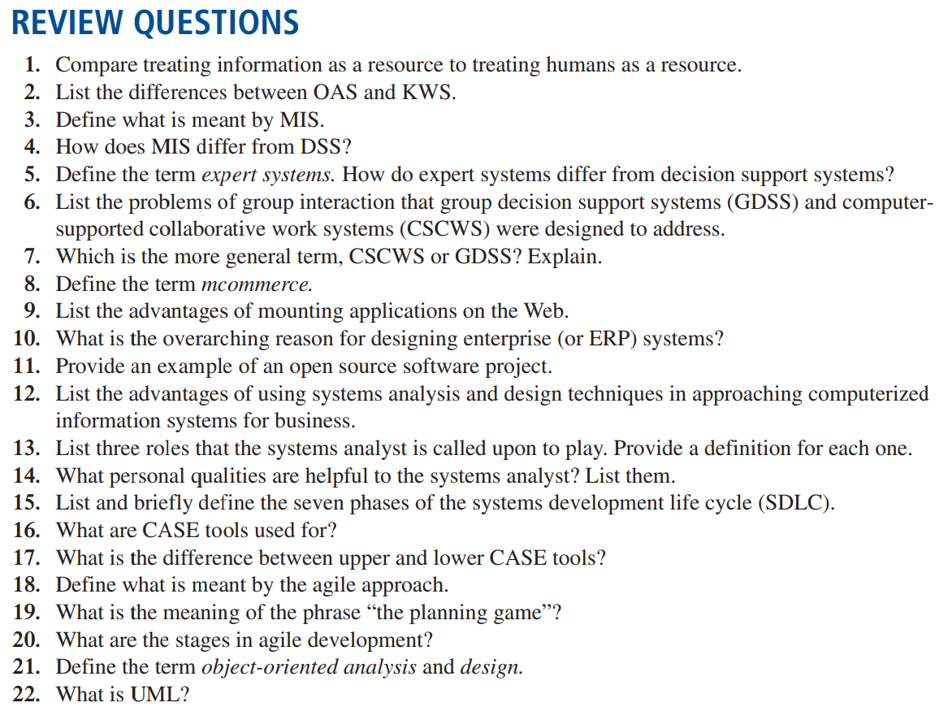

(The questions were taken from e-book. Some of the answer is interpretation from what I understand from e-book, I also takes some answer from e-book literally without changing or rephrase it, some of the answer was also from google and ChatGPT.)

I have chosen some of the question to be answered from the 21 questions.

Answer
- When we treated information as a resource, we gather and use it to perform task, store it for later use and update or discard it when we no longer needed it. On the other hand, when we treating human as a resource, it involves utilizing their skills and knowledge to perform task, but to maximize their full potential, they need to keep motivating and be productive.
- Office Automation Systems (OAS) support by data workers, who usually create new knowledge, while Knowledge Work Systems (KWS) is support by professional workers such as scientist, engineers and doctors.
- Management Information Systems (MIS) are computerized information systems which use information technology, people and business to produce information and work because of purposeful interaction between people and computers.
- Decision Support Systems (DSS) is a system that relies on data to helps people as a decision maker and solving unstructured and semi-structured problems. While, Management Information System (MIS) is a system that collection, processing and analyst data to produce information that decision maker uses to make decision.
- Expert Systems is basically a very special class of information systems for use by business as a result of widespread availability of hardware and software such as personal computers and expert system shells. DSS helps user to make a decision while Expert Systems selects the best solution for the user to solve the problem.
- GDSS and CSCWS were designed to solve semi structured and unstructured problem that a group may occur. GDSS were made to bring a group to solve a problem with the helps of many supports such as polling, questionnaire and brainstorming together. Apart from that, CSCWS were designed to help a team or group to collaborate via networked computers.
- CSCWS are more general term that GDSS. It is because CSCWS are refers to any tool that helps people work together using computers. GDSS focuses on helping groups make decision and also a specific type of CSCWS. So, basically GDSS are CSCWS but not all CSCWS are GDSS.
- Mcommerce (mobile commerce) also referred as wireless ecommerce. Mcommerce is a term that refers to any kind of business transaction that happens using a mobile device like an iPad, smartphone and laptop. In simpler words, mcommerce is when we use our phone to buy something online. This could be shopping app, ordering app even banking app. It’s like having a shop, bank, restaurant just right in our pocket.
- -Increasing user awareness of the availability of a service, product, industry, person or group
-The possibility of 24-hour access for users.
-Improving The usefulness and usability of the interface design
-Creating a system that can extend globally rather than remain local, thus reaching people in remote locations without worry of the time zone in which they are located
-Simple data management
-Increased flexibility and scalability
-Accessibility across devices
11. Mozilla Firefox
- a) System Analyst as Consultant
System analyst play a crucial role in improving efficiency of an organization’s information system. They need to have a better understanding in business requirement They also provide feedback and reports to team managers about their project performance.

b) System Analyst as Supporting Expert
System analyst also known as a tech guru in a company. They are requiring to use their knowledge about computer hardware and software to help the company achieve its goals. If there’s a problem with the computer systems, they are the ones that comes up with a solution to solve the problems.

c) System Analyst as Agent of Change
Agent of chance is the person that guide a company navigate through changes and system analyst also play a role as agent of change. They are the person who brings positive change to a company by using technology and improve the company system.

- System analyst is the individual that sees problem-solving as an exciting challenge and takes pleasure in creating practical solutions. When required, the analyst has the ability to approach problems in a methodical and organized manner.
They also require to have a good comminating skills as their soft skills. They also need to adapt with any kind of situation easily.

- CASE is an acronym for Computer Aided Software Engineering. CASE is a set of software applications designed to help developers create, maintain and manage software more efficiently. CASE also work as a productivity tool for system analyst and it also to enhance their regular activities by using automated support.
- Upper Case tools perform analysis and design and mainly use for analyst & designers.
On the other hand, lower CASE tools generate programs from CASE design and mainly use for programmers.

